**Project Sprint Retro Notes**

**Team:** 4

**Sprint:** 2

**Date:** 22/09/20

**Attended:** Will Guida, Grace Kerr, Alin Cimpean, Angela Alviano, Su-Kuen Koh

**Scrum Master:** Alin Cimpean

**Product Owner:** Sachin

**Development team:** Will Guida, Grace Kerr, Alin Cimpean, Angela Alviano, Su-Kuen Koh

## **1. Things That Went Well**

We completed almost all of our intended sprint backlog items while at the same time having other commitments to the subject such as automatic integration and testing.

## **2. Things That Could Have Gone Better**

We could have put in a few more hours this sprint in order to get the final sprint backlog item 5.1 completed, however we are still proud of the work we have done this sprint, and moving forward to sprint 3 we will do more work.

## **3. Things That Surprised Us**

We were surprised at how long the CircleCi and AWS setup tutorial actually took all of us, we spent most of this sprint setting it up which means we neglected the sprint backlog. We still completed the majority of the work we set out to do, however user story 5 must be pushed to sprint 3 and we will continue development on it then.

**4. Lessons Learned**

We planned to do quite a number of things on our sprint backlog, which inevitably we were not able to complete, this is because the work on the side of the coding, that being the AWS, docker and circleCi took up alot of our time this sprint. We now have those in a spot we’re comfortable with however it came at the expense of a few items needing to be pushed forward to sprint 3, so a lesson learnt would be to better estimate the time we will spend on activities in the future.

## **5. Burndown Chart**

This sprint we kept up with our estimated 7-8 hours of work a day pretty well, though we started off a little slowly we kept up and made up for it on other days when we could put in significantly more work so that we could be on track.

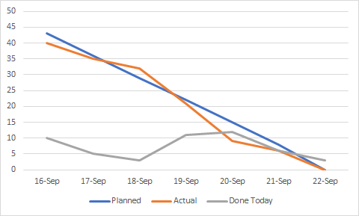

## **6. Final Thoughts**

Our final thoughts as a group is at this point everyone knows what everyone else is confident with and struggles with, this means we can pick up where another member is doing poorly and fill in the gaps. We finally setup everything else needed for the assignment such as the circle ci and AWS work from the tutorials which means we are able to now begin proper development of the website for our final submission.

## **7. Things to Change**

As of this moment, we have no intentions of changing anything from sprints 0-2 and we just have to work on upcoming sprint 3 in the future.